MYRTLE BEACH POLICE DEPARTMENT
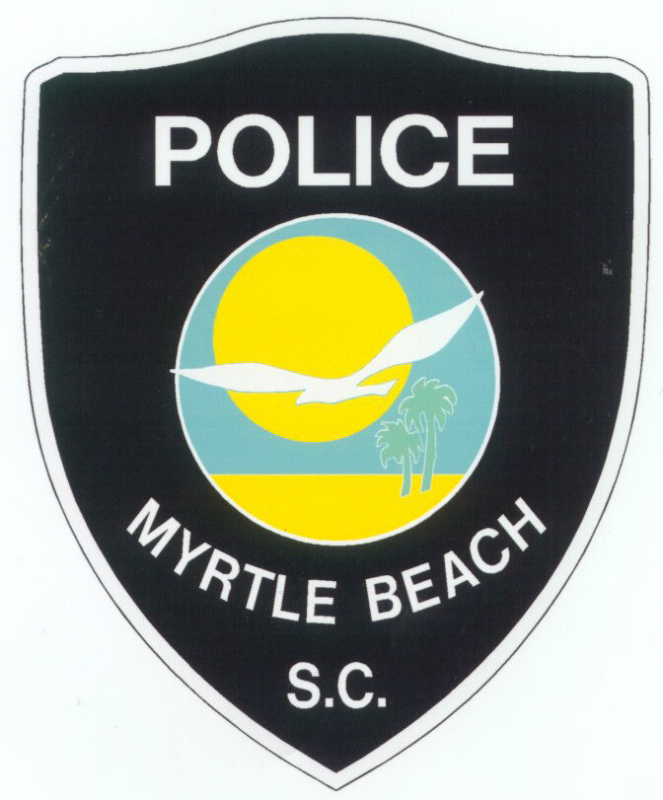
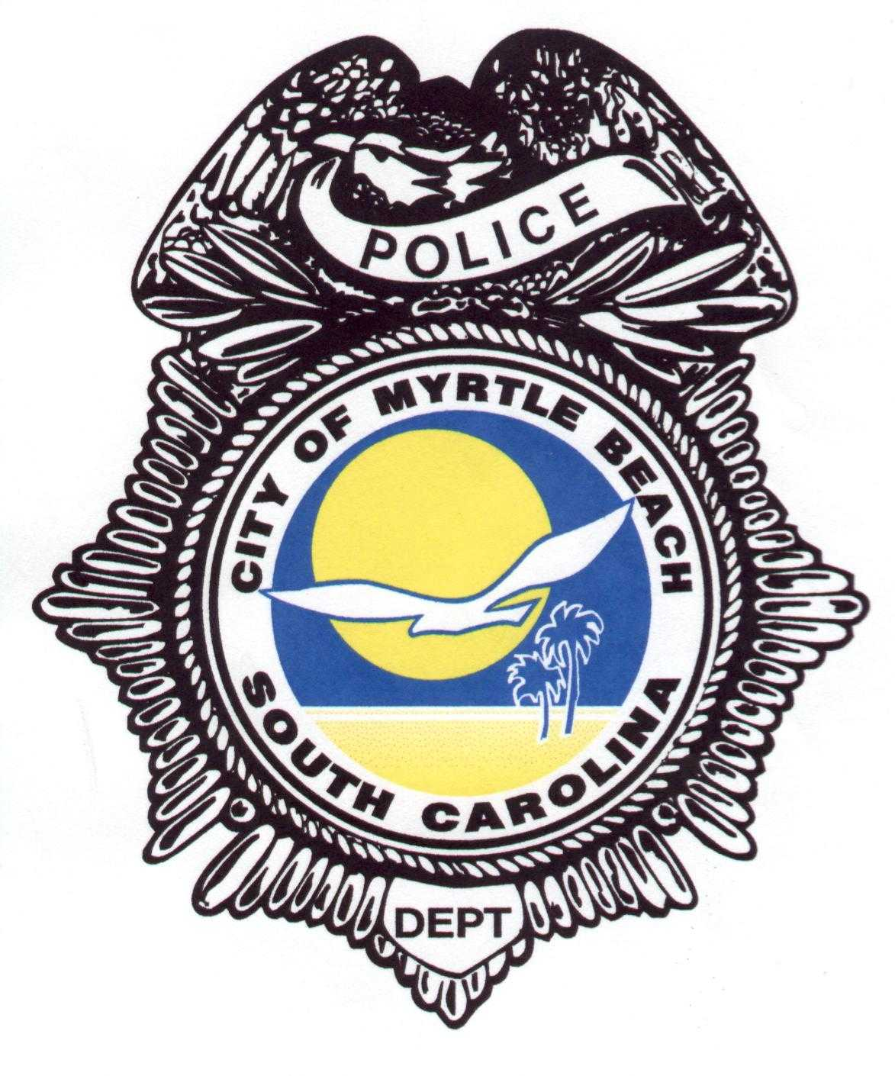

Citizens Police Academy Application Form

1101 Oak Street
Myrtle Beach, SC 29577
843-918-1800 (office)
843-918-1833 (fax)
Please Print or type all answers. If more space is needed, use an an an additional sheet of paper.
Legal Name (Last/First/Middle):

Preferred Name on Class Documents:

Street Address:

City, State, & Zip Code:

Phone #: E-Mail

Date of Birth (mm/dd/yyyy): SSN:

GENDER: MALE FEMALE

I LIVE WITHIN THE CITY LIMITS OF MYRTLE BEACH. YES NO

EMPLOYMENT

Employer:

Job Title:

Business Address:

I WORK WITHIN THE CITY LIMITS OF MYRTLE BEACH. YES NO

EDUCATION

HIGH SCHOOL: City:

College: City:

College Degree: Yes No If yes, please provide your major.

CRIMINAL HISTORY AND DRIVING RECORD

South Carolina Driver’s License Number:

Has your license ever been suspended or revoked?
Yes No If yes, please provide details, such as date, reason and length of suspension.

Have you ever been convicted of a crime? (Excluding traffic)
Yes No If yes, please provide information, such as date of arrest, charge, and disposition of case.

QUESTIONNAIRE

1. What experience have you had with Law Enforcement? (briefly Explain)

2. What is the extent of your community involvement?

3. Why do you desire to participate in this program?

4. How do you think the community, and the police department may benefit from your participation in the program?

5. What do you expect to learn from this experience?

6. Have you ever applied for the academy before? If so, when?

Commitment to Attendance

The Citizens Police Academy is a ten week program, which meets on Monday evening from 7:00pm-9:00pm. Attendance is the most important factor in reaching the desired goal of the program. Two absences are permitted; however, full attendance is encouraged.

Signature of Acknowledgement

The City of Myrtle Beach is an Equal Opportunity Employer and applies those same principles to selection of participants in the Citizen’s Police Academy. Selection is done without regard to race, religion, color, national origin, sex, age, political affiliation or disability.

ADA Notice: The City of Myrtle Beach will not discriminate against qualified individuals on the basis of disability in its services, programs or activities. The city will make all reasonable modifications to policies and programs to ensure that people with disabilities have an equal opportunity to enjoy its programs, services, and activities. Call 843-918-1114 for more information

I certify that all statements made on this application are true and complete. I understand that I may be rejected for submitting incomplete or false information. I herby authorize employees of the Myrtle Beach Police Department to make an examination of the above information for the purpose of evaluating my application.

Type in name as your electronic signature Date

IMPORTANT: This training is not designed to certify citizens to perform law enforcement services. Its purpose is to enhance community relations and to provide citizens with insight into the criminal justice system. Class size is limited. Residents and citizens who live and/or work within the city limits of Myrtle Beach are given first priority

